CSA-0908 JAVA PROGRAMMING

1. USERNAME VALIDATE

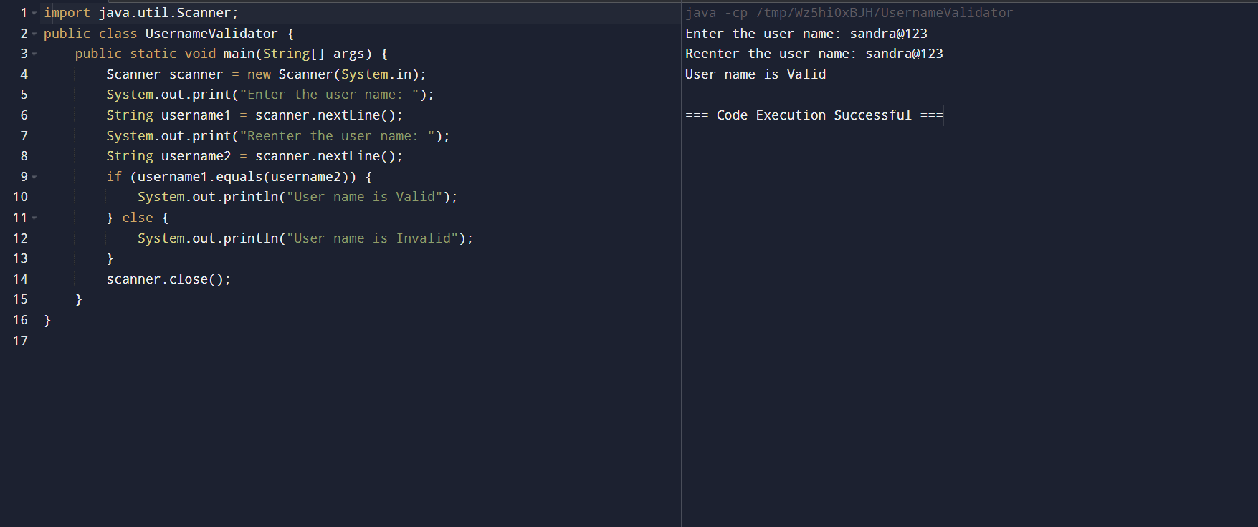

1. REVERSE NUMBER USING LOOP

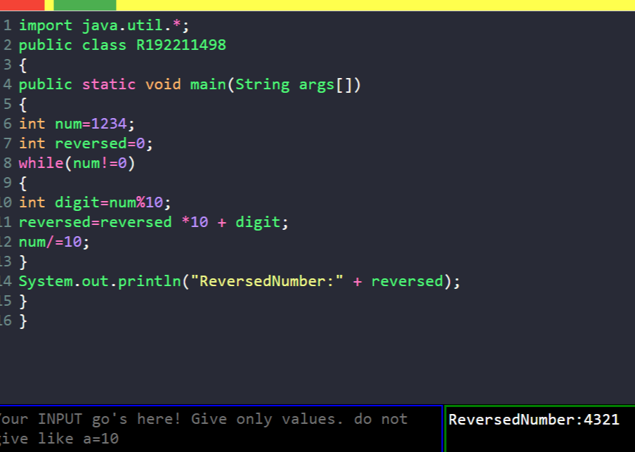

1. REVERSE WORD USING LOOP

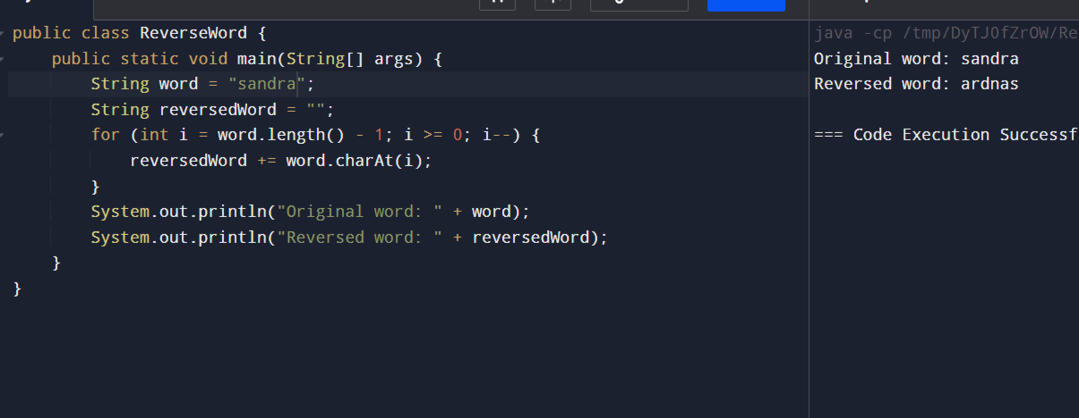

4)ELIGIBLE FOR VOTE

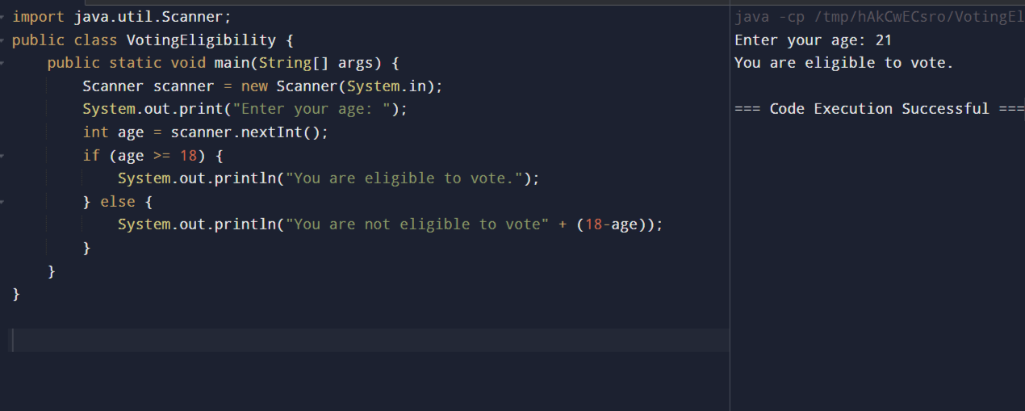

5)LCM AND GCD

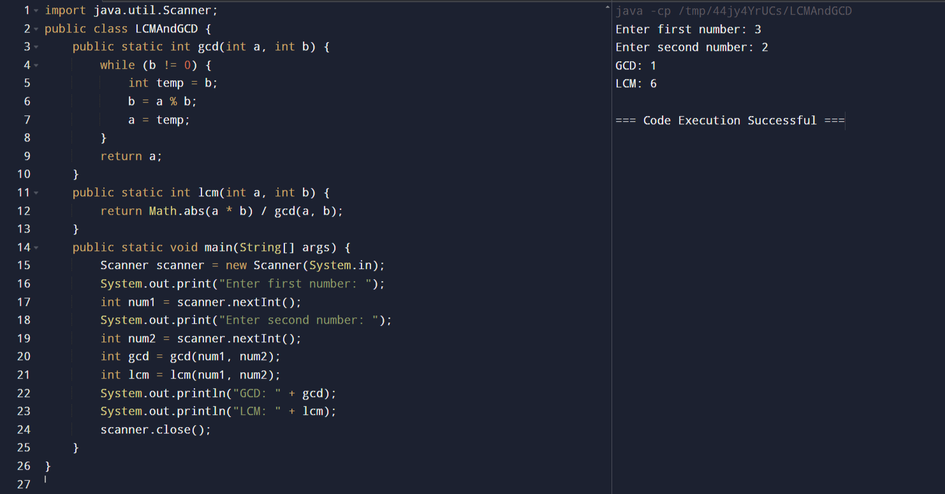

6)RIGHT TRIANGLE STAR PATTERN

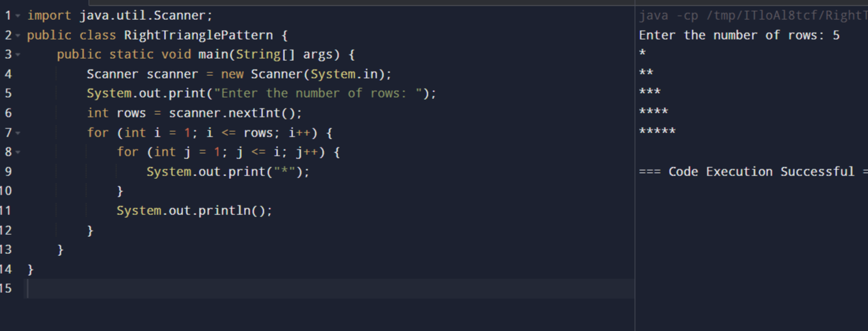

7)SIMPLE INTEREST

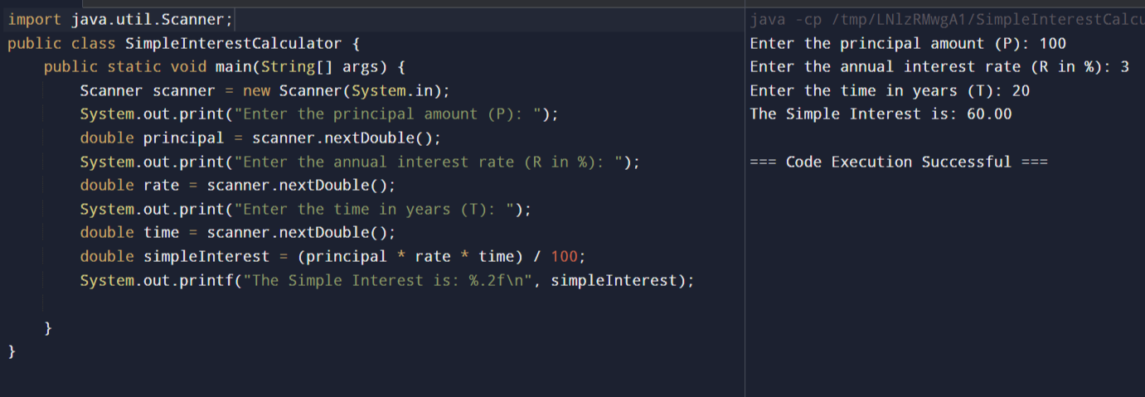

8) EVEN SUM OF FIBONACCI SERIES TILL N

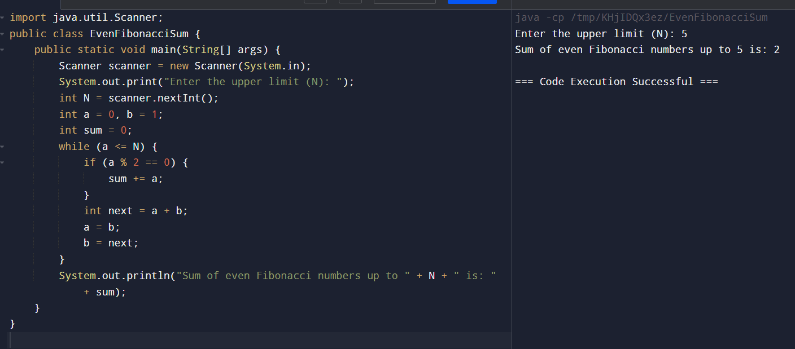

9) PRINT NUMBERS FROM M TO N BY SKIPPING K NUMBERS

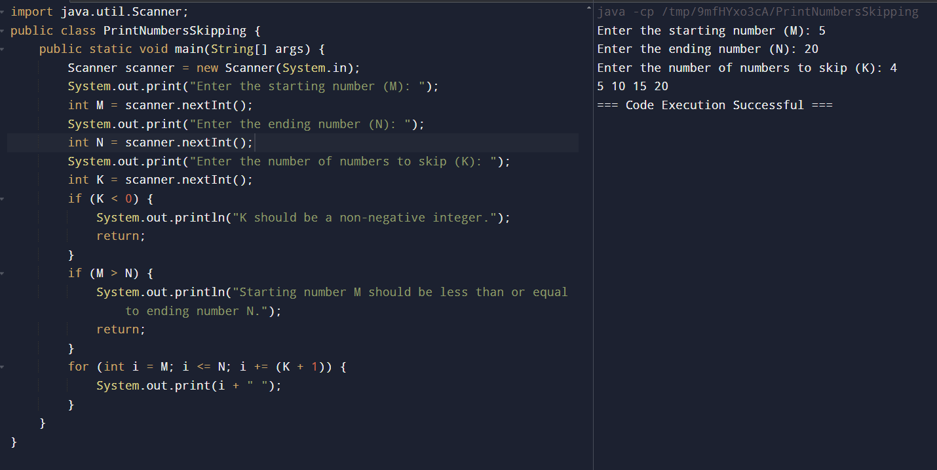

10) MATRIX ADDITION

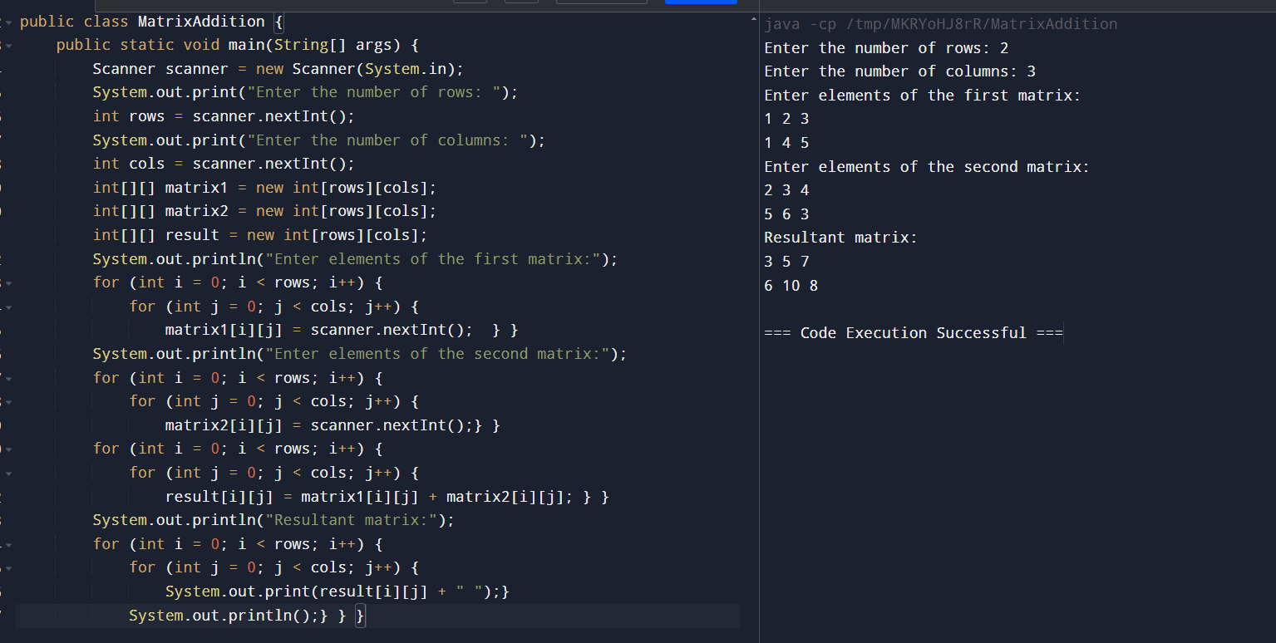

11) RECTANGLE SYMBOL PATTERN

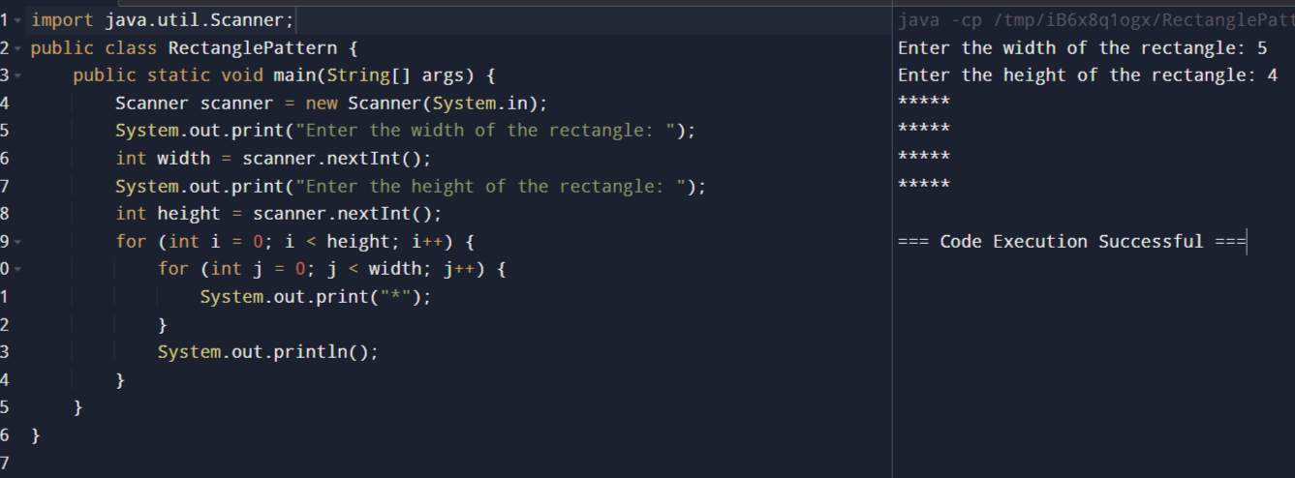

12) PATTERN PRINTER

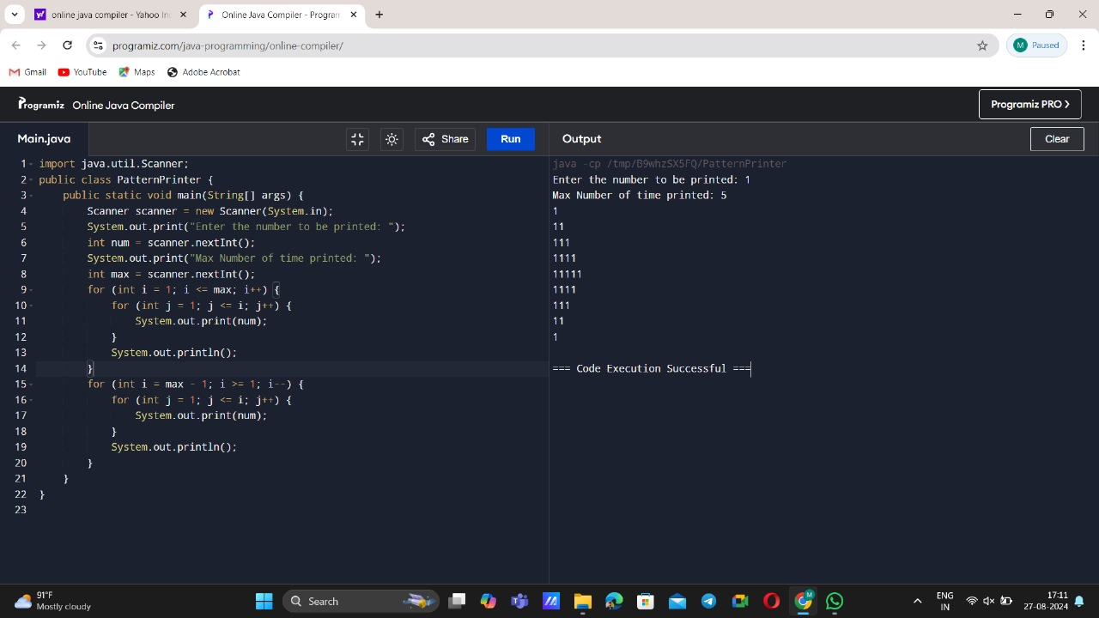

13) COMPOSITE NUMBERS

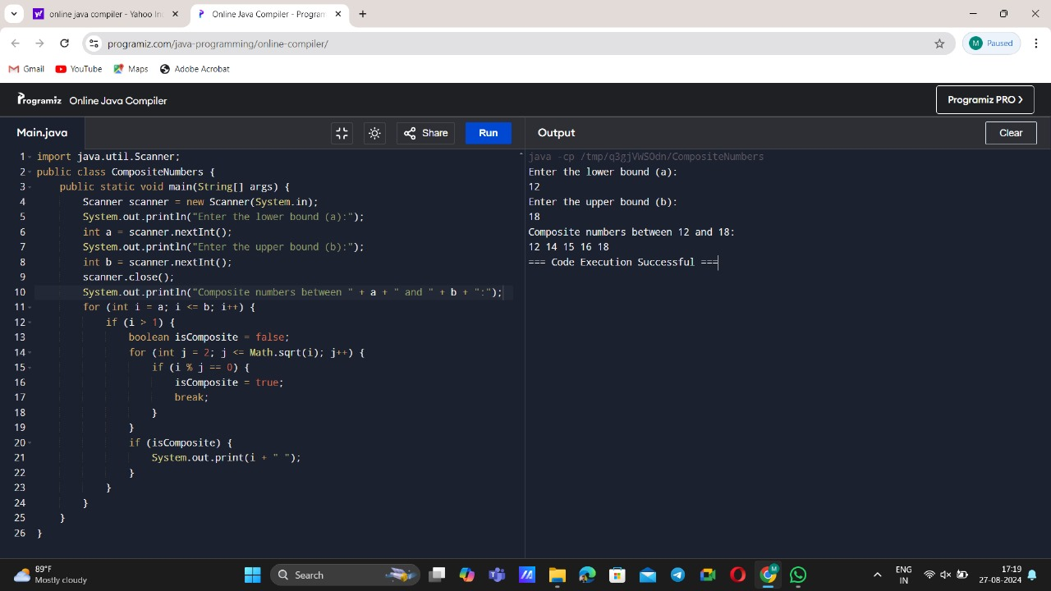

14) INVERTED FULLY PYRAMID

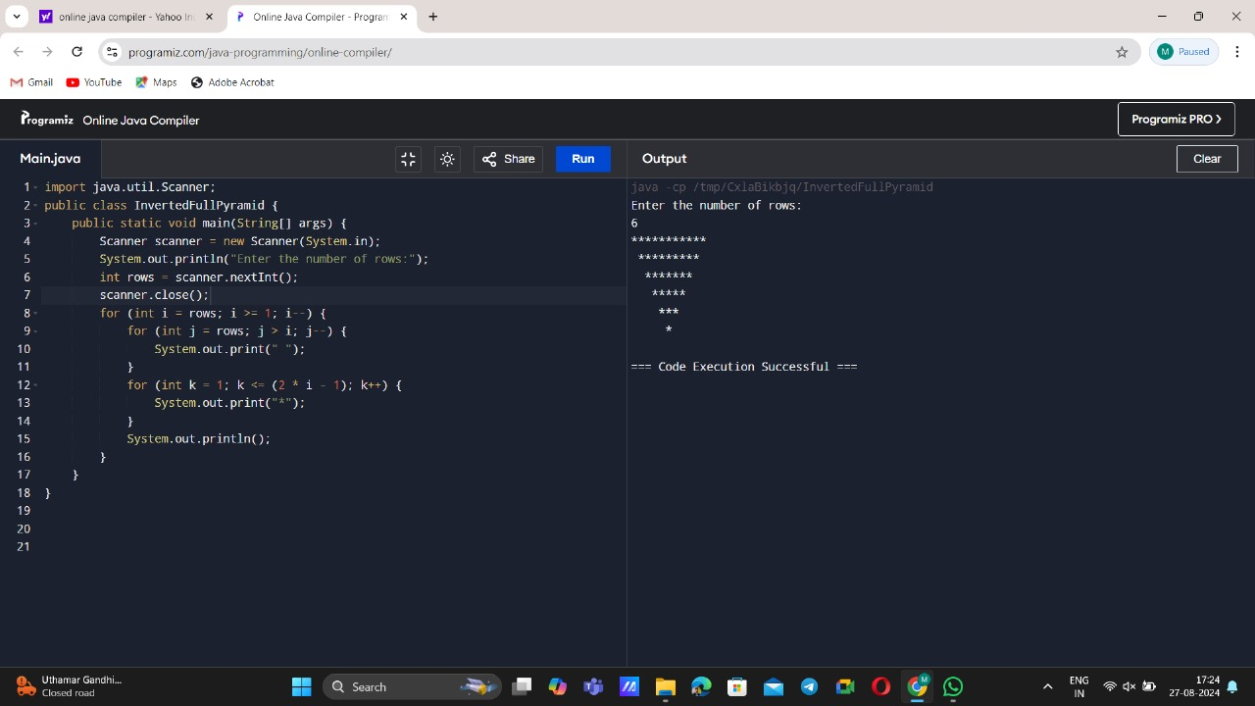

15) SPECIAL CHARACTERS

